

Version Number: 1.0

Version Date: 2019-05-06



Revision Log

|  |  |  |  |
| --- | --- | --- | --- |
| Version | Date | Author | Change Description |
| 0.1 | 2019-03-28 | Deanna Beauchamp | Initial creation |
| 1.0 | 2019-05-06 | Deanna Beauchamp | Final revisions for Phase 1 |
|  |  |  |  |
|  |  |  |  |

Contents

1. Introduction 3

1.1. Target Audience 3

2. NGN App 4

# Introduction

The full access version of Dynamics's 365 contains many entities and processes that can be confusing to end users to navigate through.

To address this user acceptance issue, Freshworks has included Dynamics 365 CRM Apps. These apps allow us to provide the users with simplified navigation and a streamlined view of information.

Note: Not all sub areas will be visible to end users based on their security

## Target Audience

The target audience for this document is business analysts, project managers and developers familiar with CRM.

# NGN App

The NGN application is used by service delivery managers and expense authorities to view the relevant entities for NGN. Access to this app is via URL or via the menu in the main Dynamics 365 site.

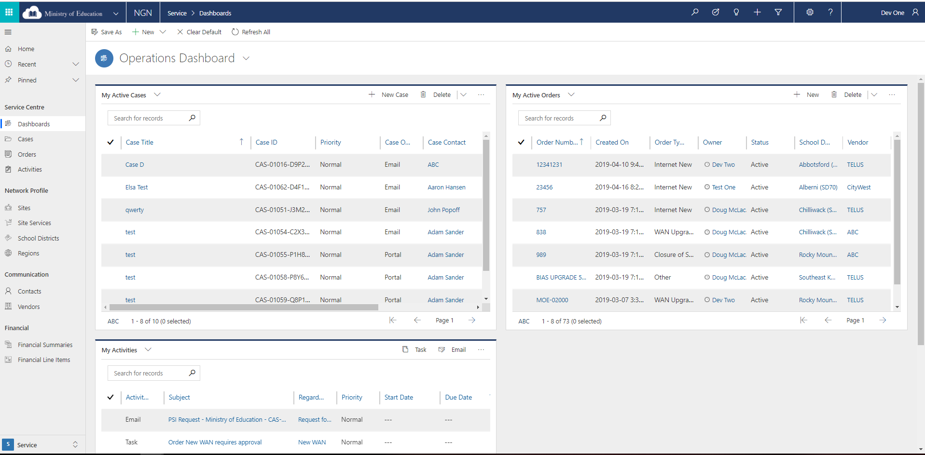

**Menu Structure**

Area: Service

Group: Service Centre

Sub Areas:

* Dashboards
* Cases
* Orders
* Activities

Group: Network Profile

Sub Areas:

* Sites
* Site Services
* School Districts
* Regions

Group: Communication

Sub Areas:

* Contacts
* Vendors

Group: Financial

Sub Areas:

* Financial Summaries
* Financial Line Items

Area: Admin

Group: Settings

Sub Areas:

* Services
* Case Categories
* Case Subcategories
* School Profiles
* Service Prices
* Service Model
* Financial Categories

**Roles**

The following roles are allowed access to the NGN App:

* NGN – Service Manager
* NGN – Expense Authority